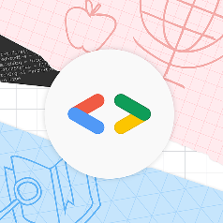 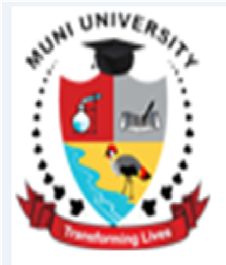

**INTERNAL MEMO**

Wed,24/08/2022

**FROM: GDSC MUNI UNIVERSITY.**

**TO: ALL STUDENTS OF MUNI UNIVERSITY.**

**GOOGLE DEVELOPERS’ STUDENTS CLUB(GDSC).**

**Greetings All,**

Allow me take this opportunity to elaborate more on GDSC. Basing on this Background, ever since I was selected as GDSC Lead Muni University by Google on Monday, 16th Aug 2022 by Google. Students have been asking me what is GDSC all about and I believe by the end of this reading, you will get a clear understanding of what GDSC is all about and I will request all students of Muni University to join the Club using the link at the end of this reading.

**What is a GDSC?**

Google Developer Student Clubs, also known as GDSCs are university-based student community groups focused on Google developer technologies. The GDSC program, started in 2019, aims to empower student developers in universities to grow as leaders and impact their student communities through technology. There are more than 250 GDSCs in Africa alone and many more in several renowned universities across the globe. These are simply hubs where students from different tech-based undergraduate and graduate programs, with an interest in leading communities of developers, bring together more students to learn the latest in technologies like Android App Development, Google Cloud, Flutter, Firebase and so much more.

**What is a GDSC Lead?**

In simple words, GDSC Leads are like the centre of a hub or the leaders of a cool tech guild that’s all about tech events and workshops.

Google Developer Student Club Leads are passionate leaders at their universities who are dedicated to helping their peers learn and connect. These Leads may be pursuing various undergraduate or graduate university degrees, but have good foundational knowledge of software development concepts.

Google collaborates with Leads and supports them as they start and grow their on-campus communities.

GDSC Leads helps their peers bridge the gap between theory and practice in understanding the intersections between social groups, technology and user behavior. Their generic roles include;

1. Spread the word and grow chapter strength and student knowledge on developer products and platforms by hosting free hands-on workshops and events (ideally once a month and at least once every 3 months). Students from nearby colleges with no GDSCs can also attend workshops at your GDSC or join your chapter virtually.
2. Identify local partners (communities/businesses/NGOs) to work with and lead project building activities that solve real-world problems in your local ecosystem.

**HOW TO JOIN OUR CLUB.**

By attending our events, workshops and hackathons .

By joining our Club community web page( using this link : <https://gdsc.community.dev/muni-university/>), click join and register. Thank you.

**Learn more here on You Tube.**

<https://www.youtube.com/watch?v=earTjC0iSjg>

<https://www.youtube.com/watch?v=DcN_hcHXR_0>

<https://www.youtube.com/watch?v=KySt9FPGD8k>

NOTE: ALL STUDENTS ARE INVITED (Anyone can learn coding, it doesn’t matter which course , what matters is your passion to develop). We shall be learning how to develop websites , android apps and more fun features related to Technology.

See you all joining the Club, you can join our even if you are doing other non-computer related courses like Nursing , education, medicine, Agriculture and others . Infact anyone from different background can code

Regards.

**ABAHO REGAN KASHOMA**

Google Developer Student Club Lead( Club President) Muni University.

B.Sc. in Information Technology

Email: [kashomaregan@gmail.com](mailto:kashomaregan@gmail.com)

Twitter:@ KashomaRegan

Tel: 0702059835/0770692325